**Software Testing Assignment**

**Module–2(Manual Testing)**

1. **What is software testing?**

Software Testing is a process used to identify the correctness, completeness, and quality of developed computer software.

1. **What is Exploratory Testing?**

Black box testing technique performed without planning and

documentation. It is usually performed by manual testers.

1. **What is traceability matrix?**

Traceability Matrix is a table which is used to trace the requirements during the Software development life Cycle. also known as Requirement Traceability Matrix – RTM

1. **What is Boundary value testing?**

Boundary value analysis is a methodology for designing test cases that concentrates software testing effort on cases near the limits of valid ranges. BVA Test cases are designed to exercise the software on and at either side of boundary Values Always results in two test cases per boundary for valid inputs and three tests cases per boundary for all inputs.

1. **What is Equivalence partitioning testing?**

Software testing technique that divides the input data of a software unit into partitions of data from which test cases can be derived. it is usually performed by the QA teams.

1. **What is Integration testing?**

The phase in software testing in which individual software modules are combined and tested as a group. It is usually conducted by testing teams.

1. **What determines the level of risk?**

A factor that could result in future negative consequences; usually expressed as impact and likelihood.

1. **What is Alpha testing?**

First of all test newly developed hardware or software in a laboratory setting. When the first round of bugs has been fixed, the product goes into beta test with actual users. For custom software, the customer may be invited into the vendor's facilities for an alpha test to ensure the client's vision has been interpreted properly by the developer.

1. **What is beta testing?**

Test of new or revised hardware or software that is performed by users at their facilities under normal operating conditions.

1. **What is component testing?**

Component testing is also known as Unit testing. Unit Testing is a level of the software testing process where individual units/components of a software/system are tested. The purpose is to validate that each unit of the software performs as designed. Unit testing is performed by development team .

1. **What is functional system testing?**

A requirement that specifies a function that a system or system component must perform.

1. **What is Non-Functional Testing?**

Testing of those requirements that do not relate to functionality.

1. **What is GUI Testing?**

GUI means Graphical User Interface. GUI testing is the process of testing the system’s GUI of the System under Test. GUI testing involves checking the screens with the controls like menus, buttons, icons, and all types of bars – tool bar, menu bar, dialog boxes and windows etc.

1. **What is Adhoc testing?**

Adhoc testing is also known as error guessing testing. Adhoc testing is an informal testing type with an aim to break the system.

1. **What is white box testing and list the types of white box testing?**

White box testing is Testing of software with complete knowledge of its internal code and logic.

The different types of White box testing:

* Statement coverage testing
* Decision coverage testing
* Condition coverage testing

1. **What is black box testing? What are the different black box testing techniques?**

Testing, either functional or non-functional, without reference to the internal structure of the component or system.

The different types of Black box testing:

* Equivalence partitioning
* Boundary value analysis
* Decision tables
* State transition testing
* Use-case Testing

1. **Mention what are the categories of defects?**

* Severity

1. Blocker (Show stopper)

2. Critical

3. Major

4. Minor

* Priority

1. P1 (High)

2. P2 (Medium)

3. P3 (Low

1. **Mention what big bang testing is?**

Testing technique which integrates individual program modules only when everything is ready. It is performed by the testing teams.

1. **What is the purpose of exit criteria?**

Purpose of exit criteria is to define when we STOP testing either at the:

* End of all testing – i.e. product Go Live
* End of phase of testing (e.g. hand over from System Test to UAT)

1. **When should "Regression Testing" be performed?**

Regression Testing should performed if ......

* Change in requirements and code is modified according to the requirement
* New feature is added to the software
* Defect fixing
* Performance issue fix

1. **What is 7 key principles? Explain in detail?**

These are the 7 key principle:

1. Testing Shows presence of Defects

Testing can show that defects are present, but cannot prove that there are no defects.

1. Defects Clustering

most operational failures of a system are usually confined to a small number of modules

1. Exhaustive Testing is Impossible

Testing everything including all combinations of inputs and preconditions is not possible.

1. Early Testing

Testing activities should start as early as possible in the development life cycle

1. Pesticide Paradox

If the same tests are repeated over and over again, eventually the same set of test cases will no longer find any new defects.

1. Testing is Context Dependent

Different kinds of sites are tested differently.

1. Absence of Errors Fallacy

If the system built is unusable and does not fulfill the user’s needs and expectations then finding and fixing defects does not help

1. 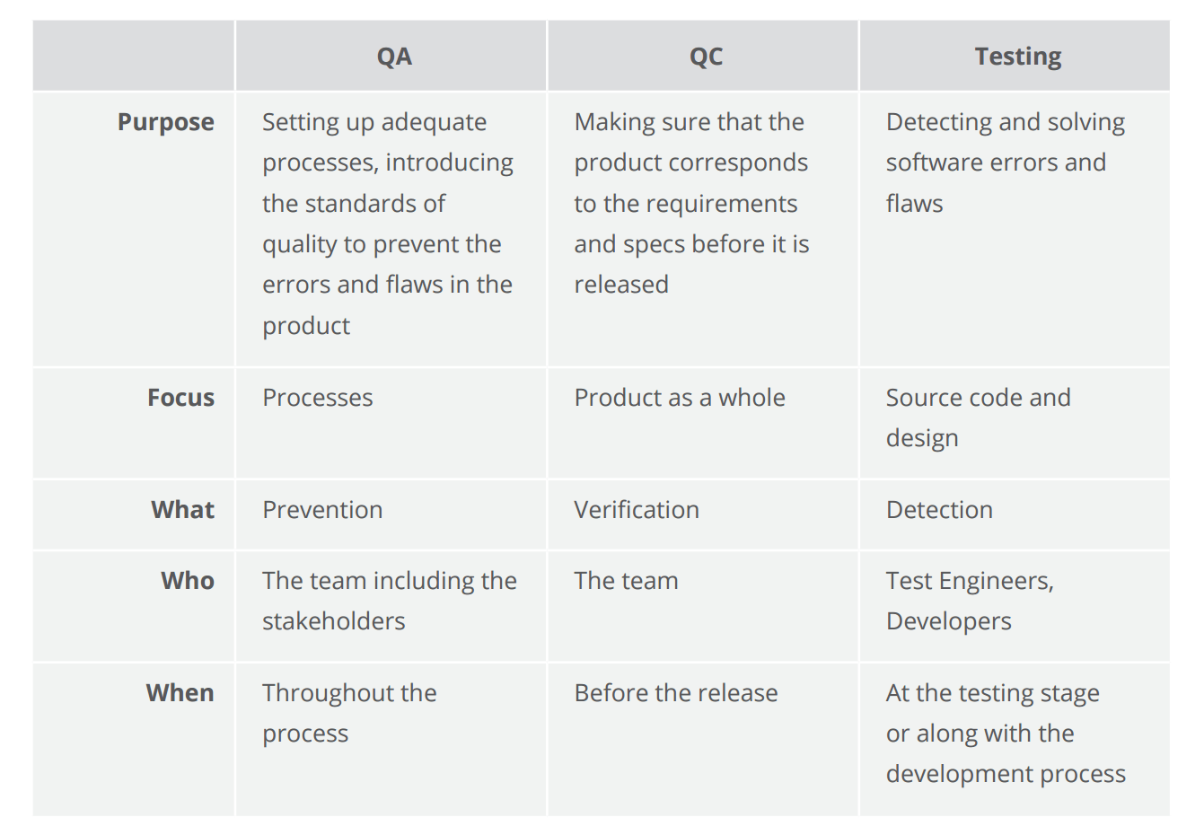**Difference between QA v/s QC v/s Tester**
2. **Difference between Smoke and Sanity?**

|  |  |
| --- | --- |
| Smoke Testing | Sanity Testing |
| Smoke Test is done to make sure the build we received from the development team is testable/stable or not | Sanity Test is done during the release phase to check for the main functionalities of the application without going deeper. |
| Smoke Testing is performed by both Developers and Testers | Sanity Testing is performed by Testers alone |
| Smoke Testing, build may be either stable or unstable | Sanity Testing, build is relatively stable |
| It is done on initial builds. | It is done on stable builds. |
| It is a part of basic testing. | It is a part of regression testing. |
| Usually it is done every time there is a new build release. | It is planned when there is no enough time to do in depth testing |

1. **Difference between verification and Validation**

|  |  |
| --- | --- |
| Verification | Validation |
| The process of evaluating work-products (not the actual final product) of a development phase to determine whether they meet the specified requirements for that phase. | The process of evaluating software during or at the end of the development process to determine whether it satisfies specified business requirements |
| Smoke Testing is performed by both Developers and Testers | Sanity Testing is performed by Testers alone |
| To ensure that the product is being built according to the requirements and design specifications. In other words, to ensure that work products meet their specified requirements. | To ensure that the product actually meets the user’s needs, and that the specifications were correct in the first place. In other words, to demonstrate that the product fulfills its intended use when placed in its intended environment |
| It is done on initial builds. | It is done on stable builds. |
| Are we building the product right? | Are we building the right product? |
| Activities • Reviews  • Walkthroughs  • Inspections | • Testing |

1. **Explain types of Performance testing.**

* Load testing
* Stress testing
* Endurance testing
* Spike testing
* Volume testing
* Scalability testing

1. **What is Error, Defect, Bug and failure?**

“A mistake in coding is called error, error found by tester is called defect, defect accepted by development team then it is called bug, build does not meet the requirements then it is failure”

1. **Difference between Priority and Severity**

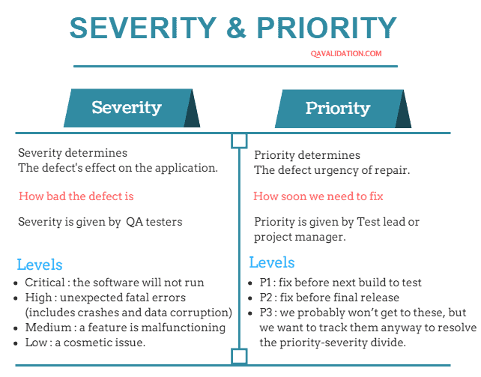

1. **What is Bug Life Cycle?**

The duration or time span between the first time defects is found and the time that it is closed successfully, rejected, postponed or deferred is called as ‘Defect Life Cycle.

Bug Life Cycle:

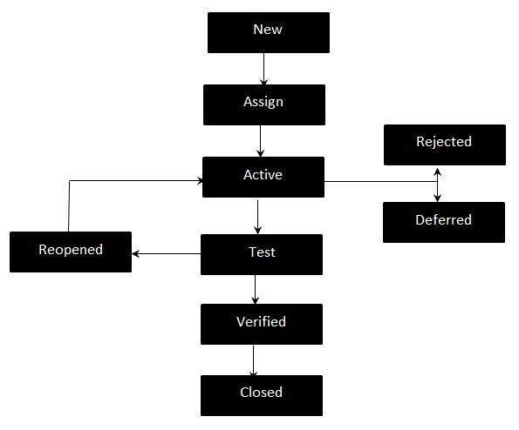

1. **Explain the difference between Functional testing and Nonfunctional testing**

|  |  |
| --- | --- |
| Functional Testing | Non-Functional Testing |
| Functional testing is performed using the functional specification provided by the client and verifies the system against the functional requirements. | Non-Functional testing checks the Performance, reliability, scalability and other non-functional aspects of the software system. |
| Functional testing is executed first | Non functional testing should be performed after functional testing |
| Manual testing or automation tools can be used for functional testing | Using tools will be effective for this testing |
| Business requirements are the inputs to functional testing | Performance parameters like speed , scalability are inputs to non-functional testing. |
| Functional testing describes what the product does | Non-functional testing describes how good the product works |
| Easy to do manual testing | Tough to do manual testing |
| Types of Functional testing are  • Unit Testing  • Smoke Testing  • Sanity Testing  • Integration Testing  • White box testing  • Black Box testing  • User Acceptance testing  • Regression Testing | Types of Non-functional testing are  • Performance Testing  • Load Testing  • Volume Testing  • Stress Testing  • Security Testing  • Installation Testing  • Penetration Testing  • Compatibility Testing  • Migration Testing |

1. **What is the difference between the STLC (Software Testing Life Cycle) and SDLC (Software Development Life Cycle)?**

|  |  |
| --- | --- |
| SDLC | STLC |
| DLC is a linear process that ensures you design and construct the proper system | but the STLC is a technique that allows you to test what you've developed thoroughly |
| SDLC is involved with the development of new systems | whereas STLC is exclusively concerned with their testing |
| Software Development Life Cycle involves the complete Verification and Validation of a Process or a Project. | Whereas Software Testing Life Cycle involves only Validation. |

1. **What is the difference between test scenarios, test cases, and test script?**

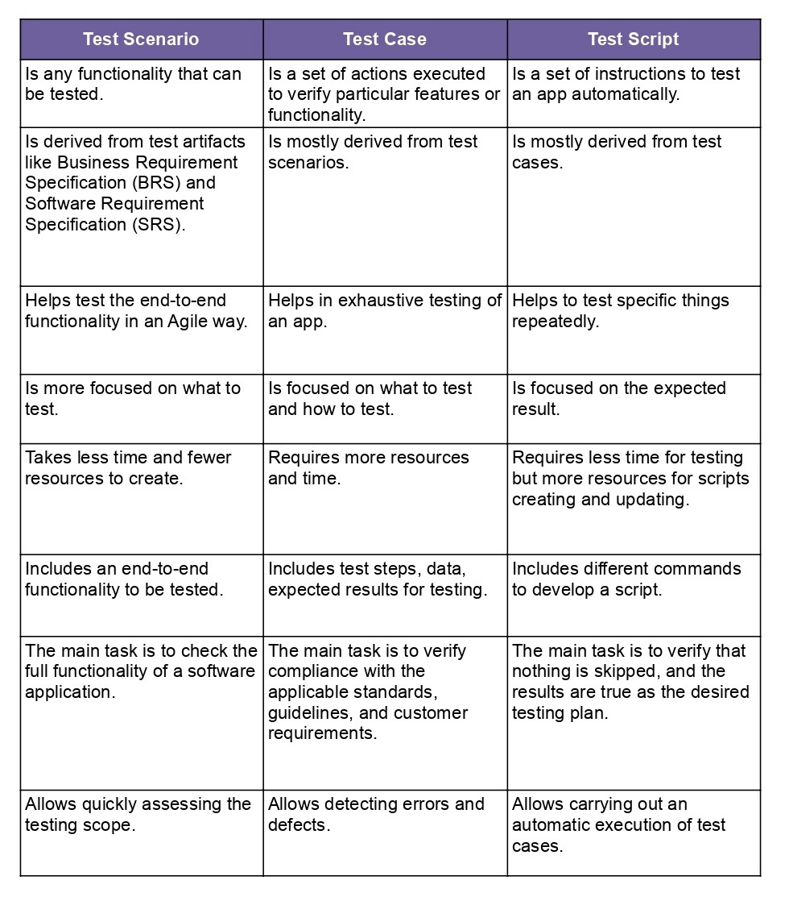

1. **Explain what Test Plan is? What is the information that should be covered.**

Test plans can be used as supporting documentation for an overall testing objective (a master test plan) and specific types of tests (a testing type-specific plan).

Important tasks in the Test Planning:

* Understanding and analysing the requirements
* Risk Analysis
* Test Estimations (Scope of the project, Time, Budget, Available resources)
* Team formation
* Test Approach (Strategy) Implementation
* Defining Test Environment setup
* Traceability Matrix
* Test Plan Documentation

1. **What are the different Methodologies in Agile Development Model?**

There are various methodologies present in agile testing and those are listed below:

• Scrum

• eXtreme Programming

Below listed methodologies are used less frequently

• Dynamic System Development Method (DSDM)

• Test Driven Development (TDD)

• Feature Driven Development

• XBreed

• Crystal

1. **Explain the difference between Authorization and Authentication in Web testing.**

* Authentication: User is valid or not.
* Authorization / Access control: Permissions of the valid user.

1. **What are the common problems faced in Web testing?**
   * Integration.
   * Interoperability.
   * Security.
   * Performance.
   * Usability.
   * Quality Testing, Exceptional Services.